ID | Severity | Line
B402 | High | 18
B507 | High | 415 / 432
B602 | High | 601
B104 | Medium | 112 / 540 / 636

3.2 Vulnerability #1

Test ID
B104 – Hardcoded Bind All Interfaces

Severity
Medium

Confidence
Medium

CWE
CWE-605

Description
The application was configured to bind to 0.0.0.0, which allows connections from all available network interfaces. This may expose the service to unauthorized access from external networks.

Location
scanner.py

CVSS v3.1 Base Score
5.3 (Medium)

def start_tcp_server(host: str = '0.0.0.0', port: int = 8888)

server.bind(('0.0.0.0', port))
parser.add_argument("--host", type=str, default='0.0.0.0')

Code Fix
Before:
host='0.0.0.0'
server.bind(('0.0.0.0', port))
parser.add_argument("--host", default='0.0.0.0')
After:
host='127.0.0.1'
server.bind(('127.0.0.1', port))
parser.add_argument("--host", default='127.0.0.1')

Result
The service now binds only to localhost (127.0.0.1), reducing network exposure and preventing unintended external access.

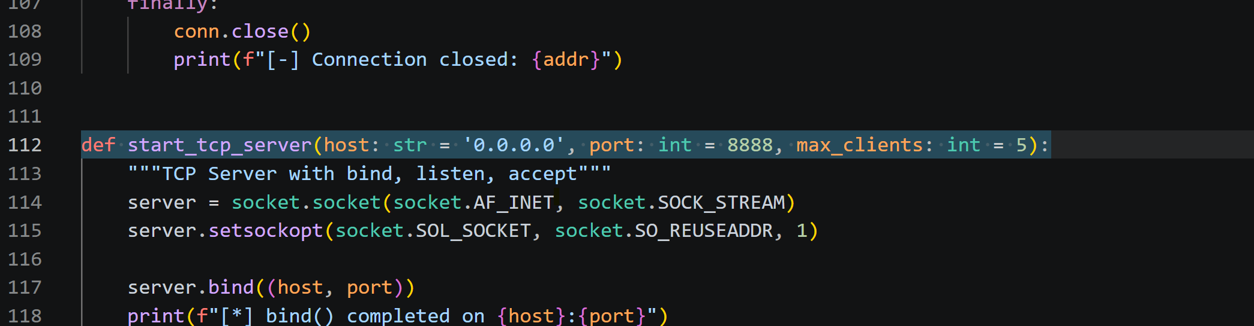
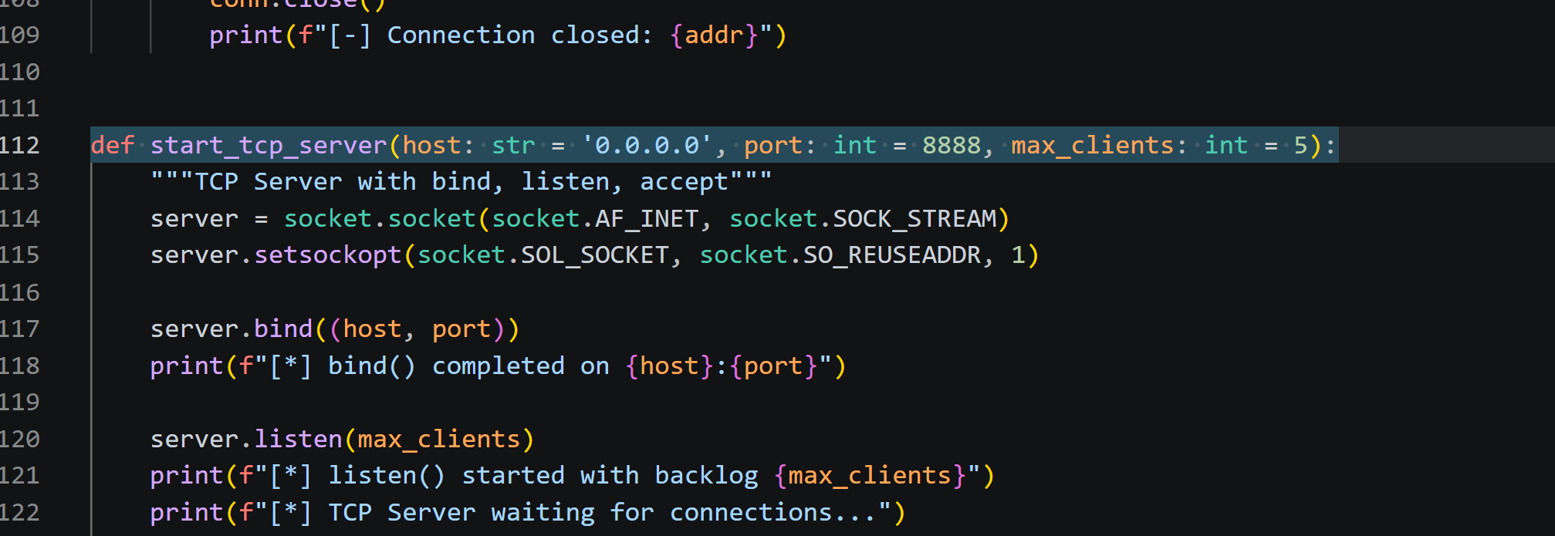

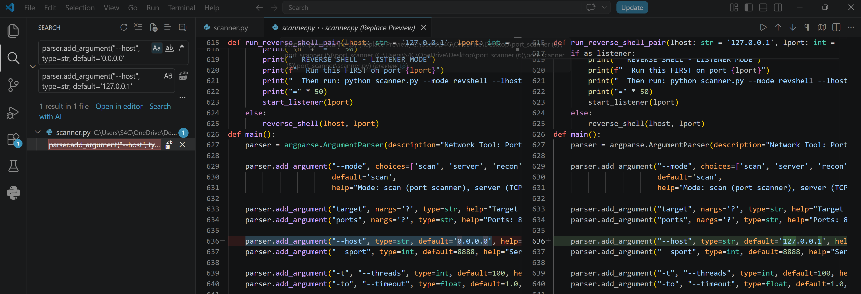
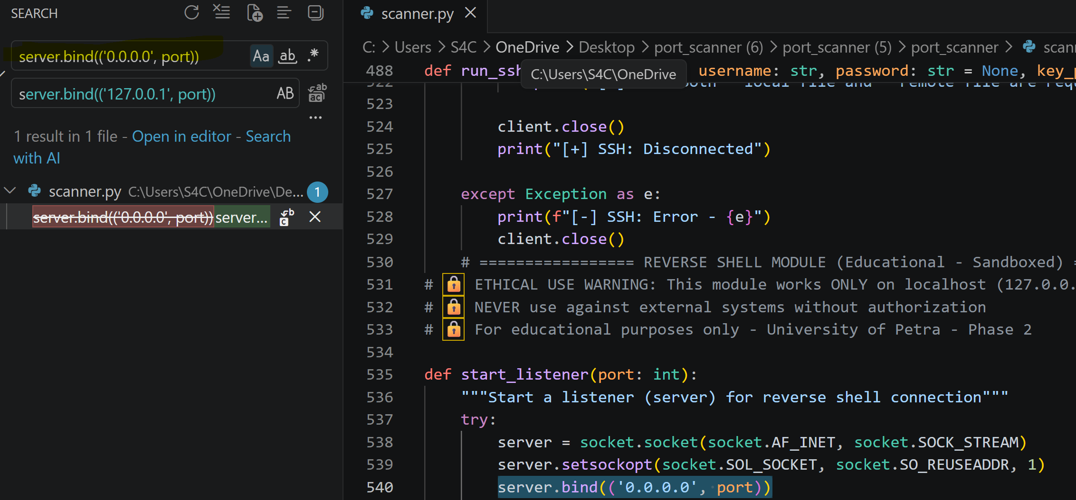

3.3 Vulnerability #2

Test ID
B507 – SSH Host Key Verification Disabled

Severity
High

Confidence
Medium

CWE
CWE-295

Description
The application automatically trusted unknown SSH host keys using Paramiko's AutoAddPolicy(). This could allow Man-in-the-Middle (MITM) attacks by accepting malicious SSH servers without verification.

Location
scanner.py (Lines 415 and 432)

Before Fix

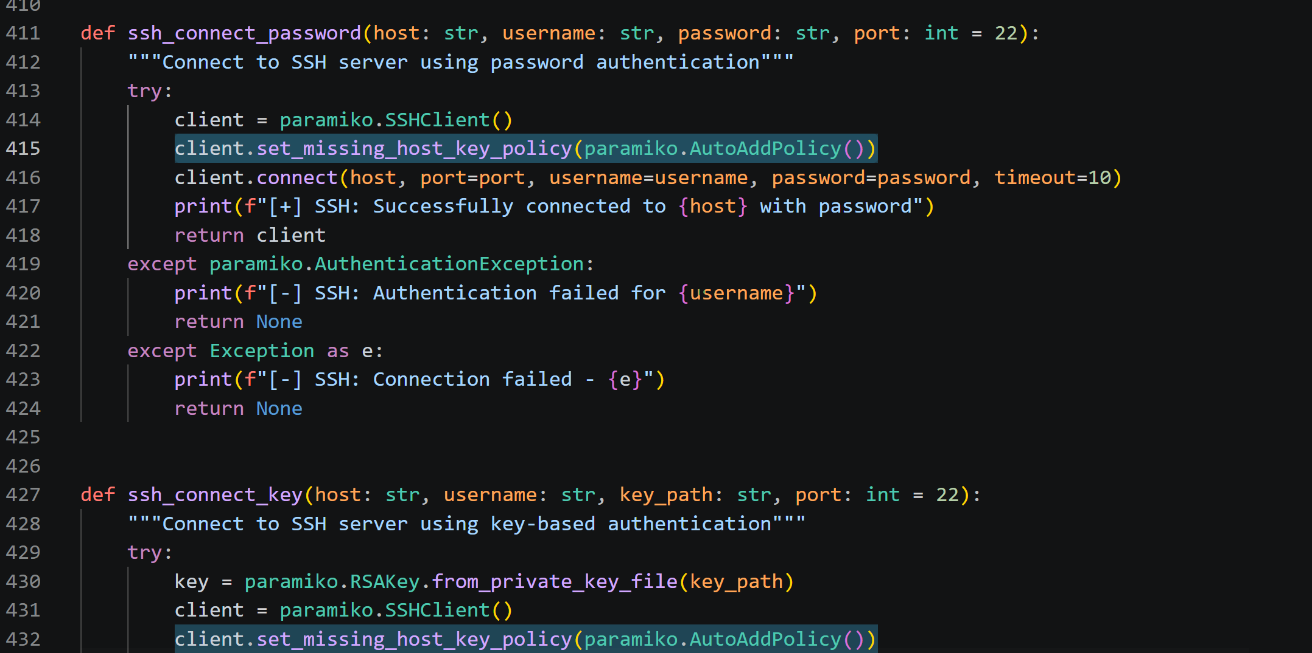

Vulnerable Code
client.set_missing_host_key_policy(paramiko.AutoAddPolicy())

Fix Applied
client.load_system_host_keys()
client.set_missing_host_key_policy(paramiko.RejectPolicy())

After Fix

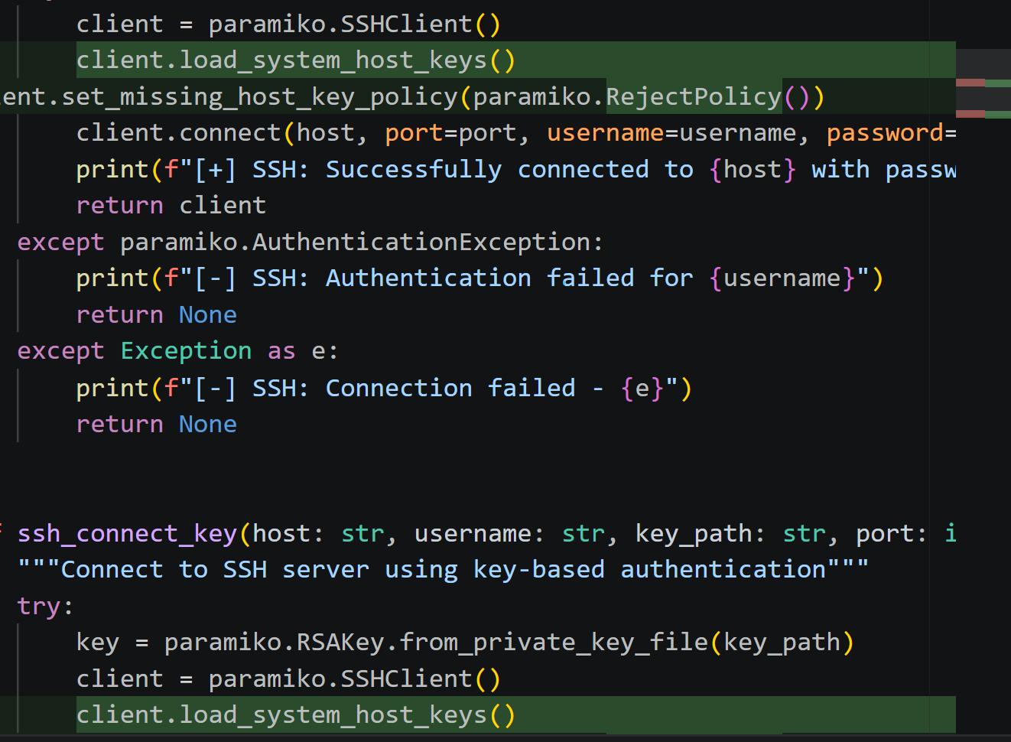

Result
The application now verifies SSH host keys before establishing connections, reducing the risk of Man-in-the-Middle attacks.

3.4 Vulnerability #3

Test ID
B602 – subprocess call with shell=True

Severity
High

Confidence
High

CWE
CWE-78

Description
The application executed system commands using subprocess.run() with shell=True. This may allow command injection if malicious input is provided.

Location
scanner.py (Line 601)

Before Fix

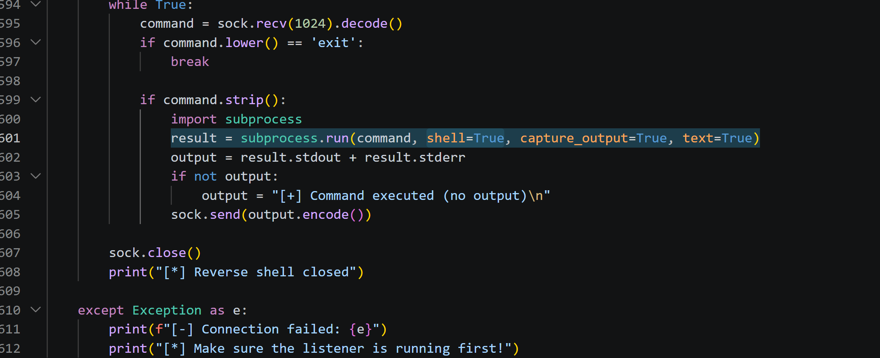

Vulnerable Code
result = subprocess.run(command, shell=True, capture_output=True, text=True)

Fix Applied
result = subprocess.run(command.split(), shell=False, capture_output=True, text=True)

After Fix

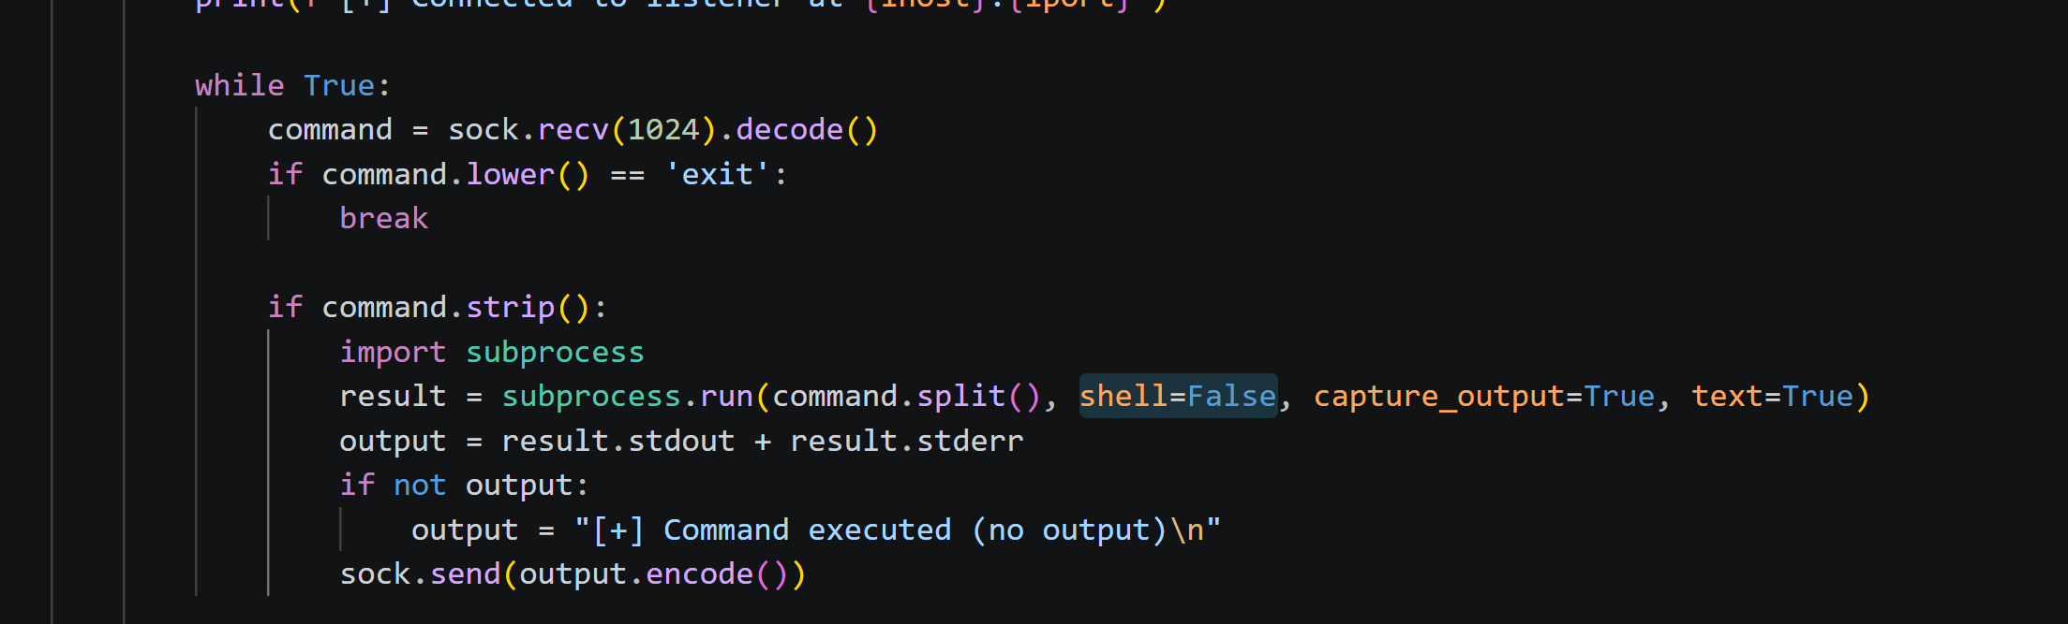

Result
The command is now executed without invoking the system shell, reducing the risk of command injection attacks.

3.5 Vulnerability #4

Test ID
B402 / B321 – Insecure FTP Usage

Severity
High

Confidence
High

CWE
CWE-319

Description
The application uses the FTP protocol through the ftplib library. FTP transmits credentials and data without encryption, making it vulnerable to eavesdropping and interception attacks.

Location
scanner.py (Lines 18 and 316)

Before Fix

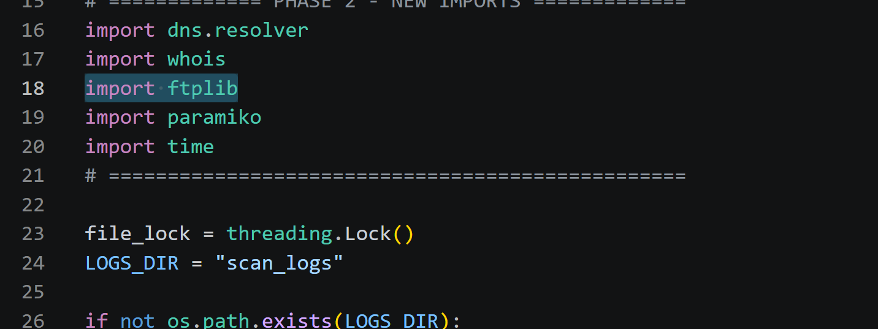
import ftplib
ftp = ftplib.FTP()
ftp.connect(host, port)

Recommended Fix
Replace FTP with SFTP using the Paramiko library, which provides encrypted file transfer over SSH.
Example:
import paramiko

transport = paramiko.Transport((host, 22))
transport.connect(username=username, password=password)

sftp = paramiko.SFTPClient.from_transport(transport)

Result
The vulnerability was identified and documented. Migration from FTP to SFTP is recommended to ensure encrypted communication and secure credential transmission.

